Standard | Items:
5.RI.02  Determine two or more main ideas of a text and explain how they are supported by key details; summarize the text. | 3.0  - Identify the main ideas of the passage Horses by Seymour Simon. What details support this main idea?  - Main Idea 1:  - Supporting Detail #1:  - Supporting Detail #2:  - Main Idea 2:  - Supporting Detail #1:  - Supporting Detail #2:  - Summarize the text in a paragraph.  Source: http://www.corestandards.org/assets/Appendix_B.pdf
2.0

American Explorers
- Identify the main ideas of the passage____________.

- Main Idea 1:

- Main Idea 2:

Public Transportation

- Summarize the text in the paragraph.

Source: http://teacher.depaul.edu/Reading_NONFICTION_Grade5.html

5.RF.04  Read with sufficient accuracy and fluency to support comprehension.  a) Read on-level text with purpose and understanding. | 3.0  1a. Billy is about to read a story book that has a picture of a knight, a dragon, and a castle on the cover. Which of the following purposes is appropriate for Billy to use?  - To learn about how to make armor and swords.  - To be entertained by a fantasy story about a knight.  - To be convinced that dragons are real.  Read the following text. Your purpose for reading is to learn about tornadoes. Then answer the questions below.  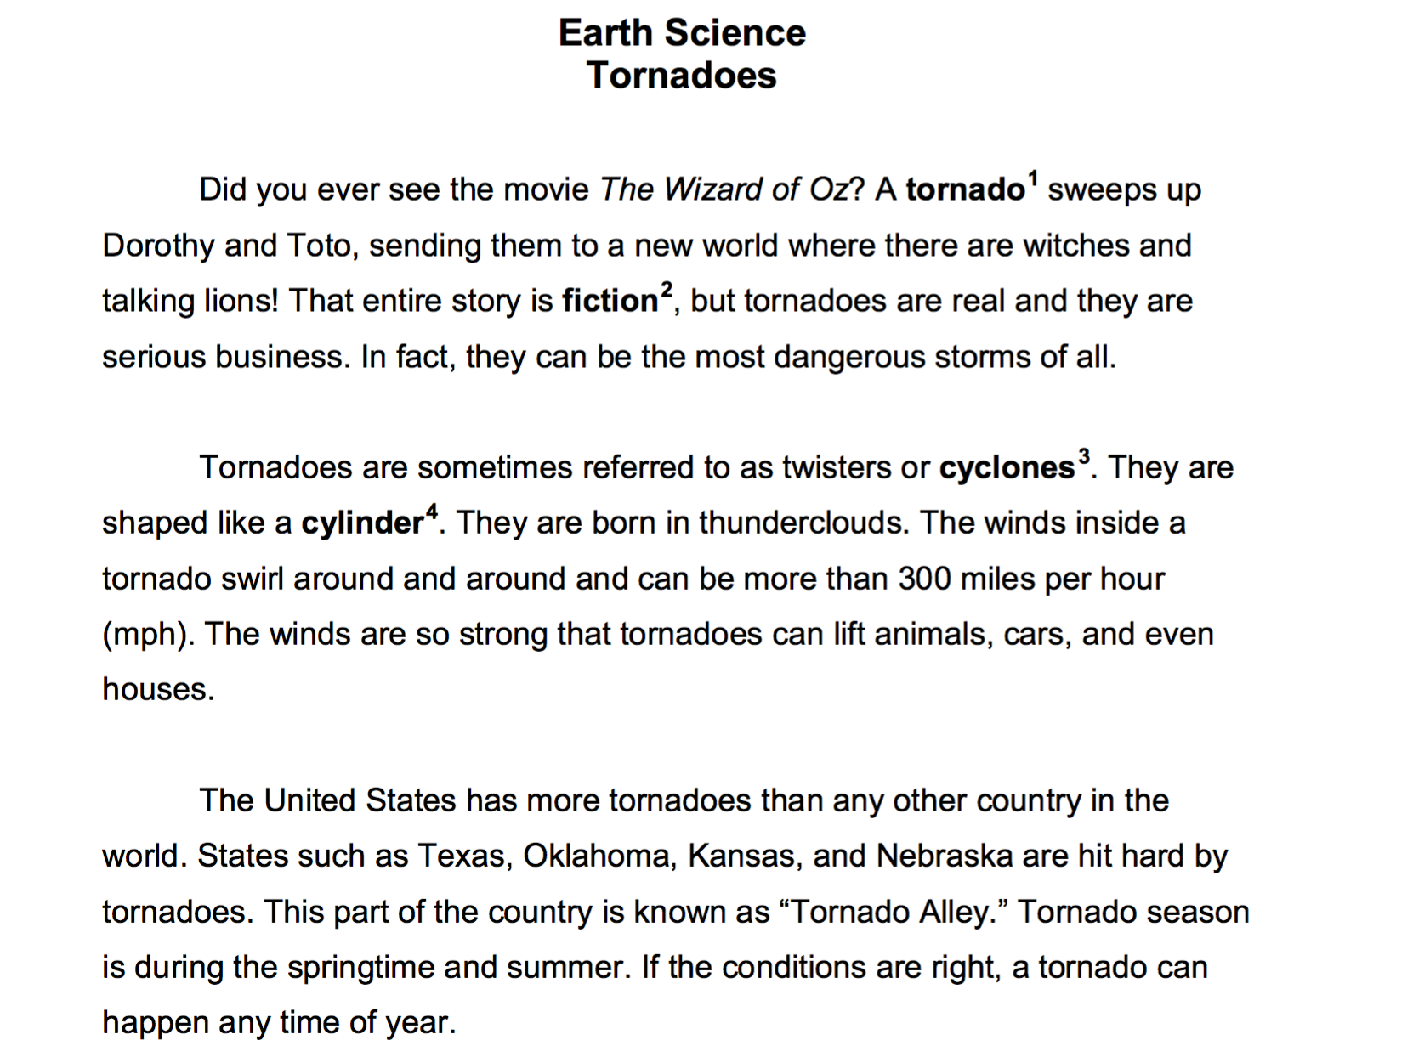  1b. Is cyclone another name for a tornado? T or F  1c. Where are tornadoes born?
2.0 Read the following text. Your purpose for reading is to learn about tornadoes. Then answer the question below.

- Which county has the most tornadoes?
5.W.03  Write narratives to develop real or imagined experiences or events using effective technique, descriptive details, and clear event sequences.  a) Orient the reader by establishing a situation and introducing a narrator and/or characters; organize an event sequence that unfolds naturally.  b) Use narrative techniques, such as dialogue, description, and pacing, to develop experiences and events or show the responses of characters to situations.  c) Use a variety of transitional words, phrases, and clauses to manage the sequence of events.  d) Use concrete words and phrases and sensory details to convey experiences and events precisely.  e) Provide a conclusion that follows from the narrated experiences or events. | 3.0  Tell about an experience you had during recess.  Be sure to:  - Introduce a narrator and/or characters  - Organize an event sequence that unfolds naturally  - Use a variety of transitional words, phrases, and clauses to manage the sequence of events  - Use narrative techniques, such as dialogue, description, and pacing to develop the experience and events  - Use concrete words and phrases and sensory details  - Provide a conclusion to your experience
2.0
Write three different introductions to a story about an argument you might have with your friend. (*could be a graphic organizer with some of the parts of the story filled in and they would have to fill in the introduction -OR- picture boxes telling parts of a story)

Write three different conclusions to a story about an argument you might have with your friend. (*could be a graphic organizer with some of the parts of the story filled in and they would have to fill in the conclusion -OR- picture boxes telling parts of a story)

Pretend you are writing a story about your morning routine after waking up. Write three details, in order, that you would include.
5.L.02  Demonstrate command of the conventions of standard English capitalization, punctuation, and spelling when writing.  a) Use punctuation to separate items in a series.  b) Use a comma to separate an introductory element from the rest of the sentence.  c) Use a comma to set off the words yes and no (e.g., Yes, thank you), to set off a tag question from the rest of the sentence (e.g., It’s true, isn’t it?), and to indicate direct address (e.g., Is that you, Steve?) | 3.0 (add extra space to normal spacing)  Look at this note that Joe wrote to his friend Sally. Add commas where needed.  Sally I was so excited about my birthday party on Saturday. My mom bought games balloons and a cake. Later that day all of us went to a movie. Yes I was tired after such a fun day. That’s the sign of a great birthday isn’t it? This was such a great day! No I would not have changed a thing.
2.0
Punctuate the following sentences correctly using commas.

Mary brought apples bananas and pears to the picnic.

Because the bike was in the street a car ran over it.

Yes you may have two pieces of candy.

No you can’t go outside right now.

That’s alright with you isn’t it?

Remember to bring your lunch box Carl.

